Given a binary tree root and an integer target, delete all the **leaf nodes** with value target.

Note that once you delete a leaf node with value target**,**if it's parent node becomes a leaf node and has the value target, it should also be deleted (you need to continue doing that until you can't).

**Example 1:**

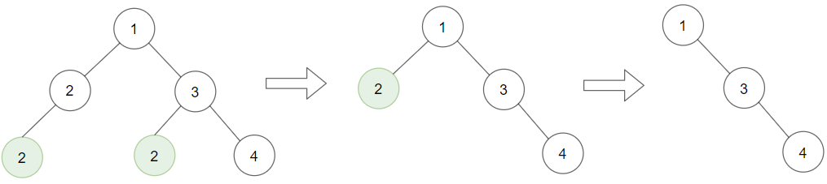

**Input:** root = [1,2,3,2,null,2,4], target = 2

**Output:** [1,null,3,null,4]

**Explanation:** Leaf nodes in green with value (target = 2) are removed (Picture in left).

After removing, new nodes become leaf nodes with value (target = 2) (Picture in center).

**Example 2:**

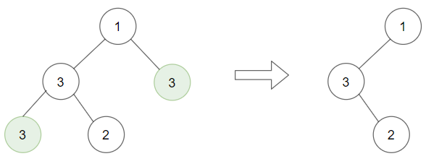

**Input:** root = [1,3,3,3,2], target = 3

**Output:** [1,3,null,null,2]

**Example 3:**

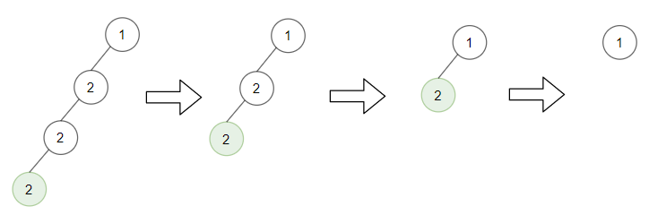

**Input:** root = [1,2,null,2,null,2], target = 2

**Output:** [1]

**Explanation:** Leaf nodes in green with value (target = 2) are removed at each step.

**Example 4:**

**Input:** root = [1,1,1], target = 1

**Output:** []

**Example 5:**

**Input:** root = [1,2,3], target = 1

**Output:** [1,2,3]

**Constraints:**

* 1 <= target <= 1000
* The given binary tree will have between 1 and 3000 nodes.
* Each node's value is between [1, 1000].